# HW 8 251/502

Please provide feedback on the progress you’ve made thus far and what other visuals would be of interest along with any questions you may have re homework solutions or preparation for your project.

Adjust your Tableau heatmap from HW 7 to match the one below.

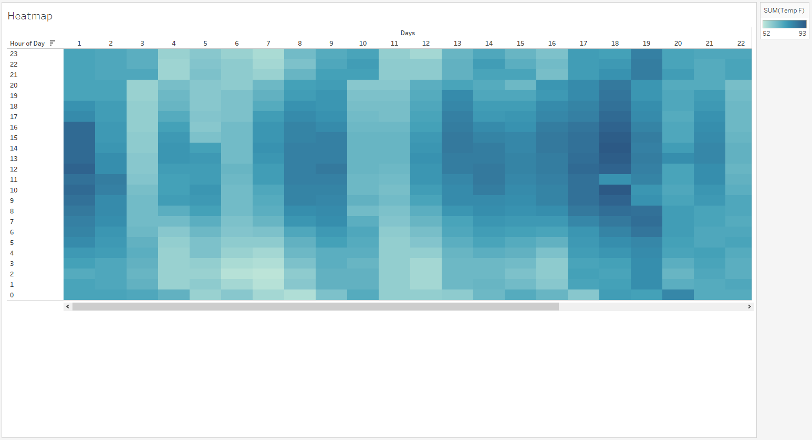

# Adjusted Heatmap in Tableau:

